Body Part Project¡¡DIBUJA! Un monstruo o extraterrestre

-Must use at least 12 different vocabulary body parts
-Label each body part in Spanish (spelled correctly)
-Must be colored. Not on lined paper The drawing should take up the majority of the page.
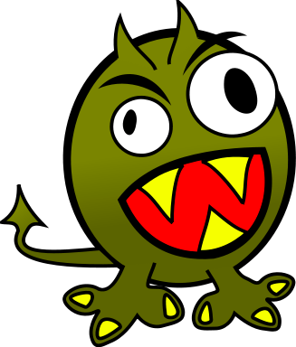
el ojo
la boca
las piernas
Nombre: Paco
Origin: Venezuela
Edad: 32 meses
Pasatiempos: estudiar español, visitar lugares interestantes, y…
Write this information on the front:
(do not put into sentences)
Nombre:
Origen:
Edad:
Pasatiempos:

Do not write anything else on the paper.

When it is due, you will present your monster orally to the class. Describe it, saying what makes it unique. For example: Mi monstruo tiene cinco ojos. Y tiene tres dientes en el pie derecho. (2-3 body parts)
Also, give its name, origen, age, and hobbies and what it can or can not do well. Example: Le gusta pasear en los parques. Puede cantar muy bien porque tiene una boca grande. No puede hacer tarea porque no tiene dedos.
Do not write these out. You will NOT read during your presentation.
Total: 30 points: drawing and presentation

Write your 12 different body parts here (and also label on picture):
1.
Grading

Turn this sheet in for grading

Drawing:
12 body parts spelled correctly _______/12
Neat/Colored _______/ 5

Presentation:
Describes drawing ______/5
Communicated well (grammar) ______/3
Does not read, speaks only Spanish ______/5

Total: ______ /30
2.
3.
4.
5.
6.
7.
8.
9.
10.
11.

